External Provider Document Upload Instruction

When logging into SPOT, first navigate to ‘Claim Submission (AP)’
Then to ‘Upload/Scan Provider Claim Documentation
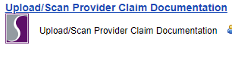

Once there, you will see the Customer Record search screen. Search for and pull up the customer that you are uploading documentation for.
Click on the blue highlighted ‘Provider Claim Documents’ link to the right of the customer name.
Next, select ‘Add Provider Claim Document.’ This can be found in the upper right hand corner.

Enter the date of the document (NOT the date that you are uploading the document).
Form Type. This is a drop down list, choose the applicable document type.
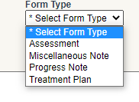

Choose ‘Upload.’
You will see the option to choose a file from your computer OR you can drag and drop the file into the rectangle area.
*If you do not keep electronic records you will need to scan them into your computer, save, and upload.

Notes. Not required however indicating what the document is (CLS log, etc.) makes locating easier.

Click ‘Save and Continue to Send Copy to’
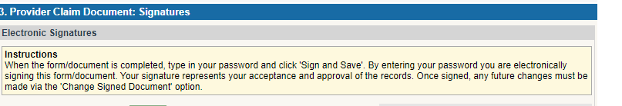
Sign with your password – your signature is indicating that you are uploading actual clinical documents that correspond to the claims being submitted.

Done.

*Please note that claims will not pay if there are no corresponding service notes uploaded into SPOT.

